**Shri Ramdeobaba College of Engineering and Management, Nagpur**

**Department of Electronics Engineering**

**Digital Image Processing (ENT 355-3)**

**Name:** Prajwal Pandurang Shette

**Roll No:** B1- 12

**Experiment No: 03**

**Aim**: Python program to perform Mathematical operations on images.

i. Arithmetic Operations

a. Addition , b. Subtraction, c. Multiplication, d. Division

ii. Logical Operation -> NOT, OR, AND

**Software Used**: Python, Vs Code, Open Cv, Matplotlib

1. **Arithmetic Operations**
2. **Addition**

**Code:**

import cv2

import numpy as np

image1 = cv2.imread('image1.jpg')

image2 = cv2.imread('image2.jpg')

weightedSum = cv2.addWeighted(image1, 0.6, image2, 0.5, 0)

cv2.imshow('Weighted Image', weightedSum)

if cv2.waitKey(0) & *0x*ff == 27:

    cv2.destroyAllWindows()

**Input Images:**

 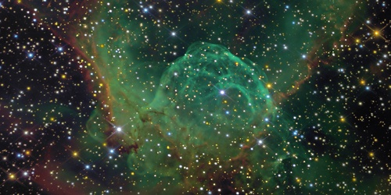

Image1 Image2

**Output**:

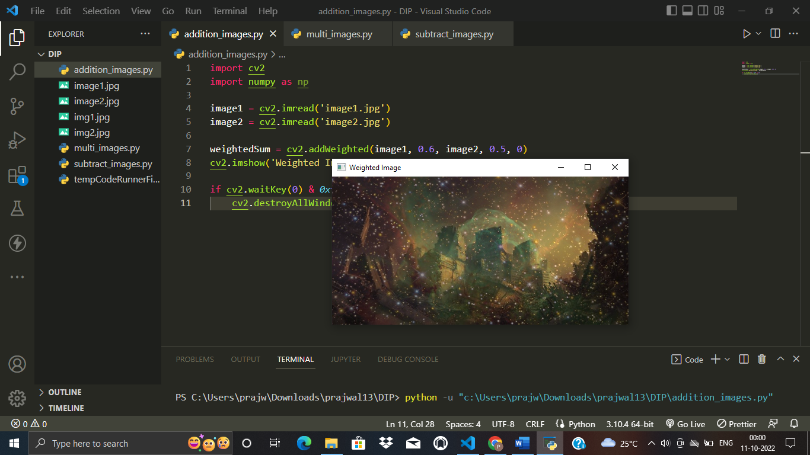

1. **Subtraction**

**Code:**

import cv2

import numpy as np

image1 = cv2.imread('image1.jpg')

image2 = cv2.imread('image2.jpg')

sub = cv2.subtract(image1, image2)

cv2.imshow('Subtracted Image', sub)

if cv2.waitKey(0) & *0x*ff == 27:

    cv2.destroyAllWindows()

**Output:**

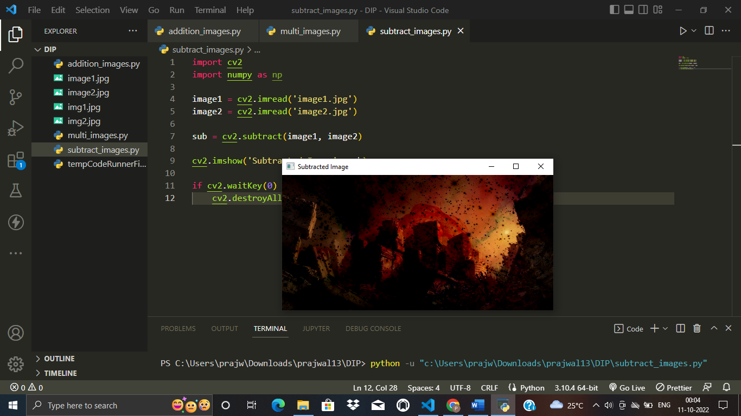

1. **Multiplication**

**Code:**

import cv2

import numpy as np

img11 = cv2.imread('image1.jpg')

img22 = cv2.imread('image2.jpg')

result_image = cv2.multiply(img11, img22)

cv2.imshow('Multiply Image', result_image)

cv2.waitKey(0)

cv2.destroyAllWindows()

**Output:**

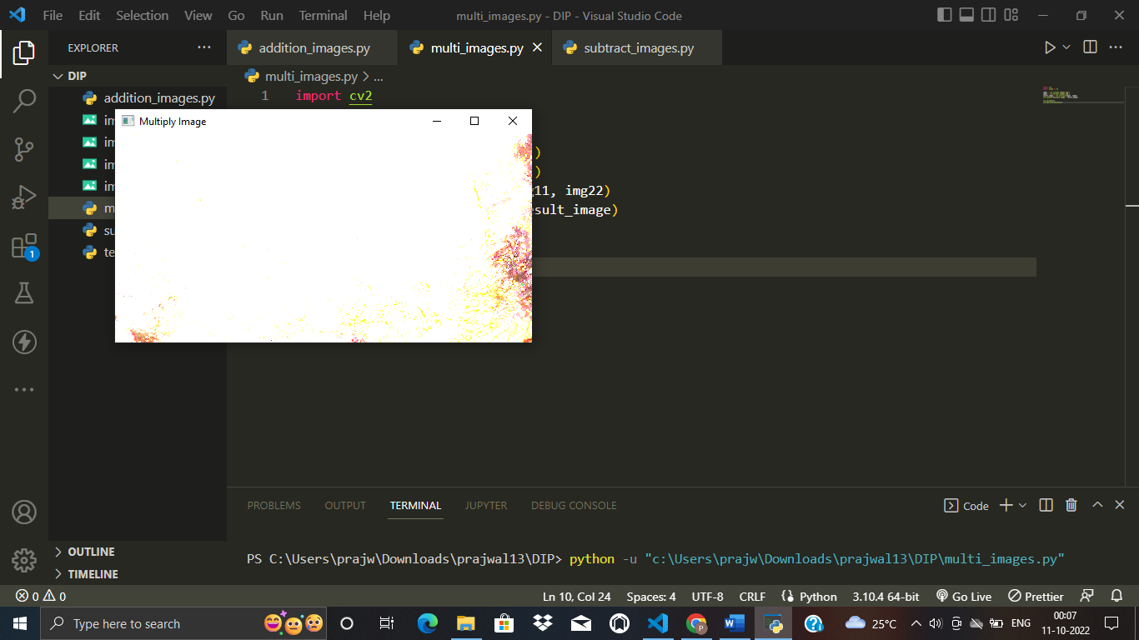

1. **Division**

**Code:**

import cv2

import numpy as np

# Reading image file

img = cv2.imread('image1.jpg')

# Applying OpenCV scalar division on image

fimg = cv2.divide(img, 2)

# Saving the output image

cv2.imwrite('image2', fimg)

**Output:**

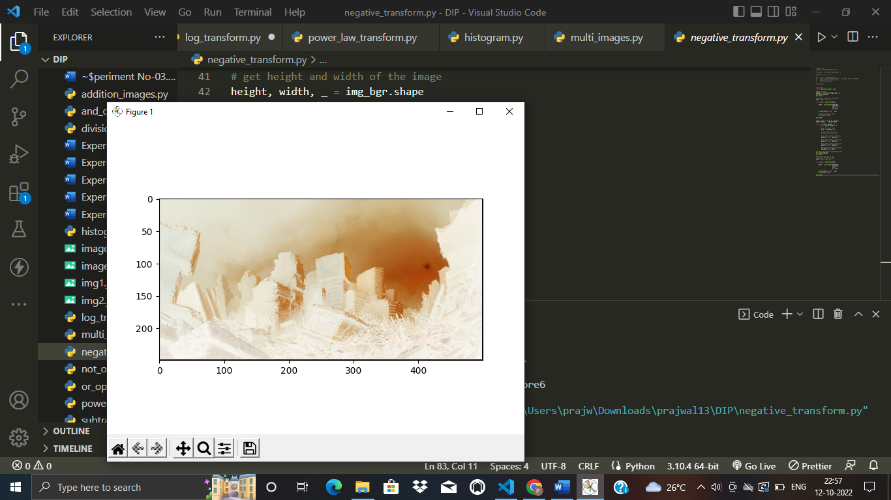

ii) **Logical Operation**

1. **AND**

**Code:**

import cv2

img1 = cv2.imread("image1.jpg")

img2 = cv2.imread("image2.jpg")

bitwise_and = cv2.bitwise_and(img2, img1)

cv2.imshow("bit_and", bitwise_and)

cv2.waitKey(0)

cv2.destroyAllWindows()

**Output:**

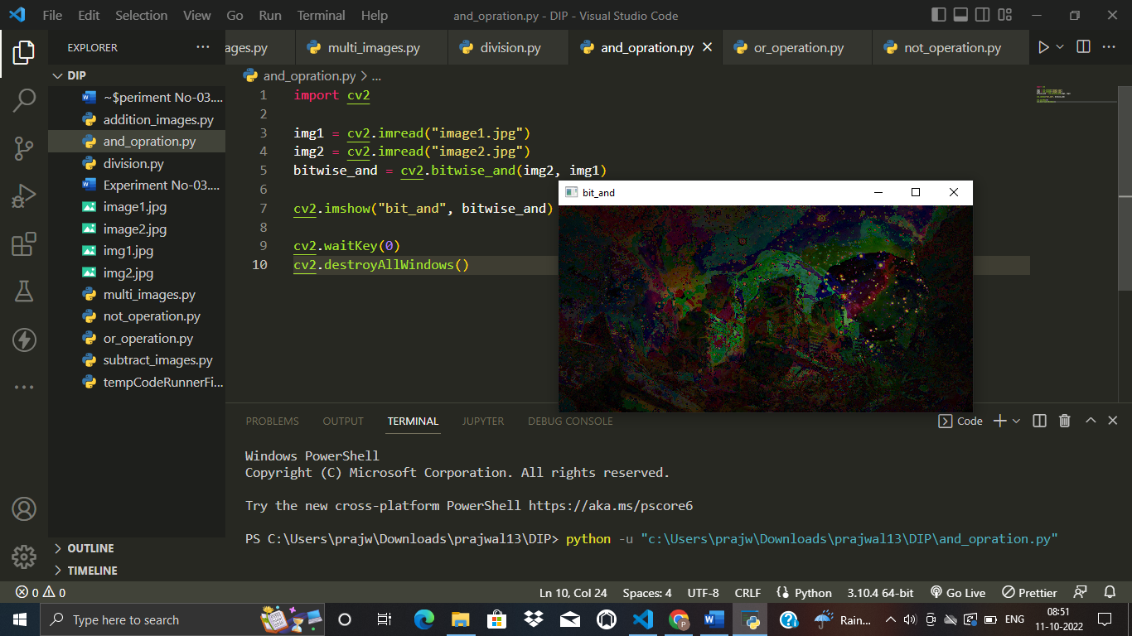

1. **OR**

**Code:**

import cv2

img1 = cv2.imread("image1.jpg")

img2 = cv2.imread("image2.jpg")

bitwise_or = cv2.bitwise_or(img2, img1)

cv2.imshow("bitwise_or", bitwise_or)

cv2.waitKey(0)

cv2.destroyAllWindows()

**Output:**

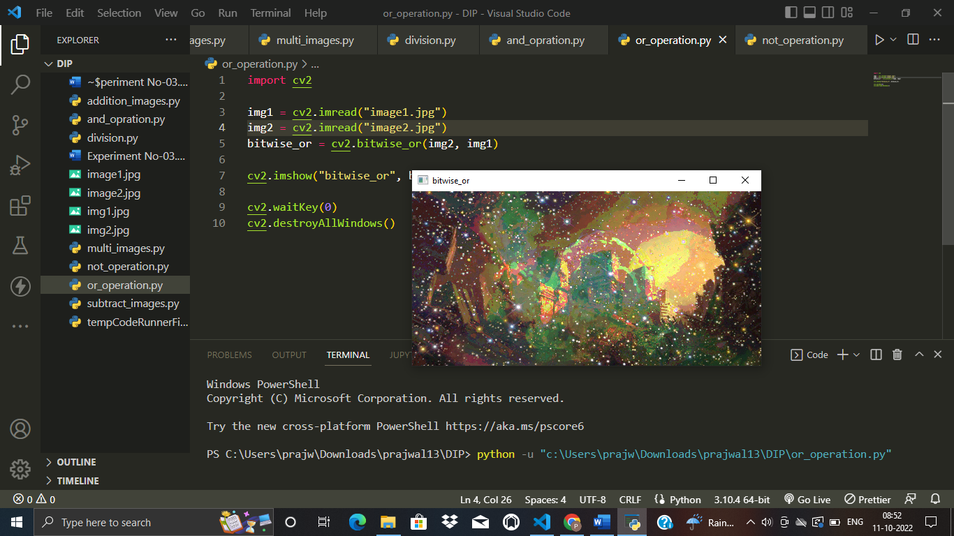

1. **NOT**

**Code:**

import cv2

img2 = cv2.imread("image1.jpg")

bitwise_not = cv2.bitwise_not(img2)

cv2.imshow("bitwise_not", bitwise_not)

cv2.waitKey(0)

cv2.destroyAllWindows()

**Input Image:**



**Output Image:**

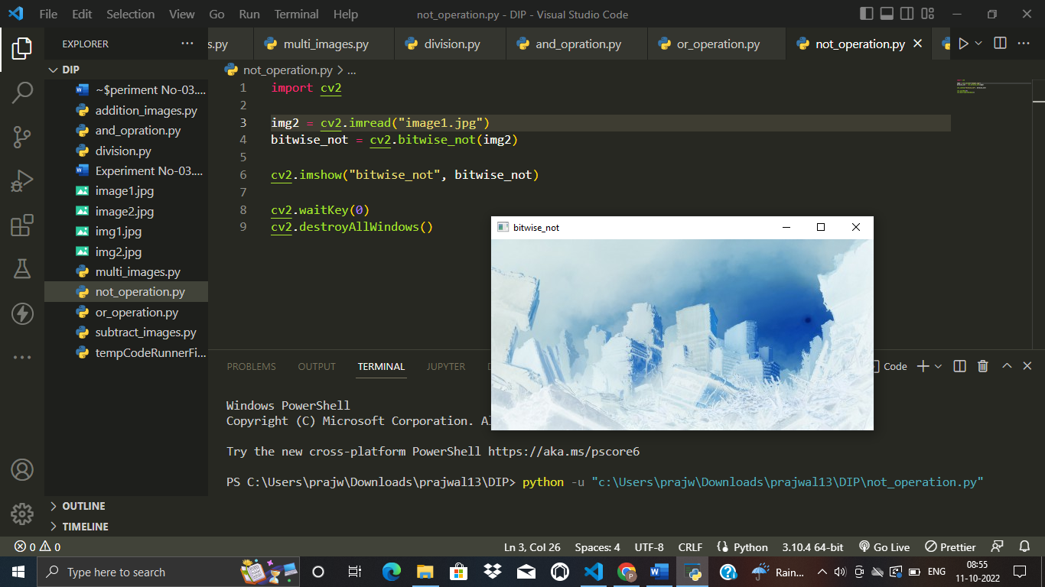

**Conclusion :**

In this Experiment we have learned how to perform different arithmetic operations on images, analyzed the working of different OpenCV methods used for performing image arithmetic, and learned where these image arithmetic operations.